|  |  |  |  |  |  |
| --- | --- | --- | --- | --- | --- |
| Date | 6-Dec-22 | | | Tester Name | Mayuri Patel |
| Environment | Penfax - Test | | | Login used |  |
| Operating System | Select OS | Version: | Update: | | |
| Software Used | Select Software | Version: | Update: | | |
| Select Software | Version: | Update: | | |
| Release version | 22.4.1 | | | | |
| Title |  | | | | |
| Test Type | Regression | | | | |
| Test Scenario | Process an interfund transfer the same day as a lump sum payment | | | | |
|  |  | | | | |
| Expected Results |  | | | | |
| Pass/Fail | Pass | | | JIRA# | N/A |

Describe your steps with screenshots:

1. 1st Lump sum payment through Penfax and 2nd inter fund transfer through Penfax

Find a PEPP member for lump sum payment and Interfund transfer

Open that member profile

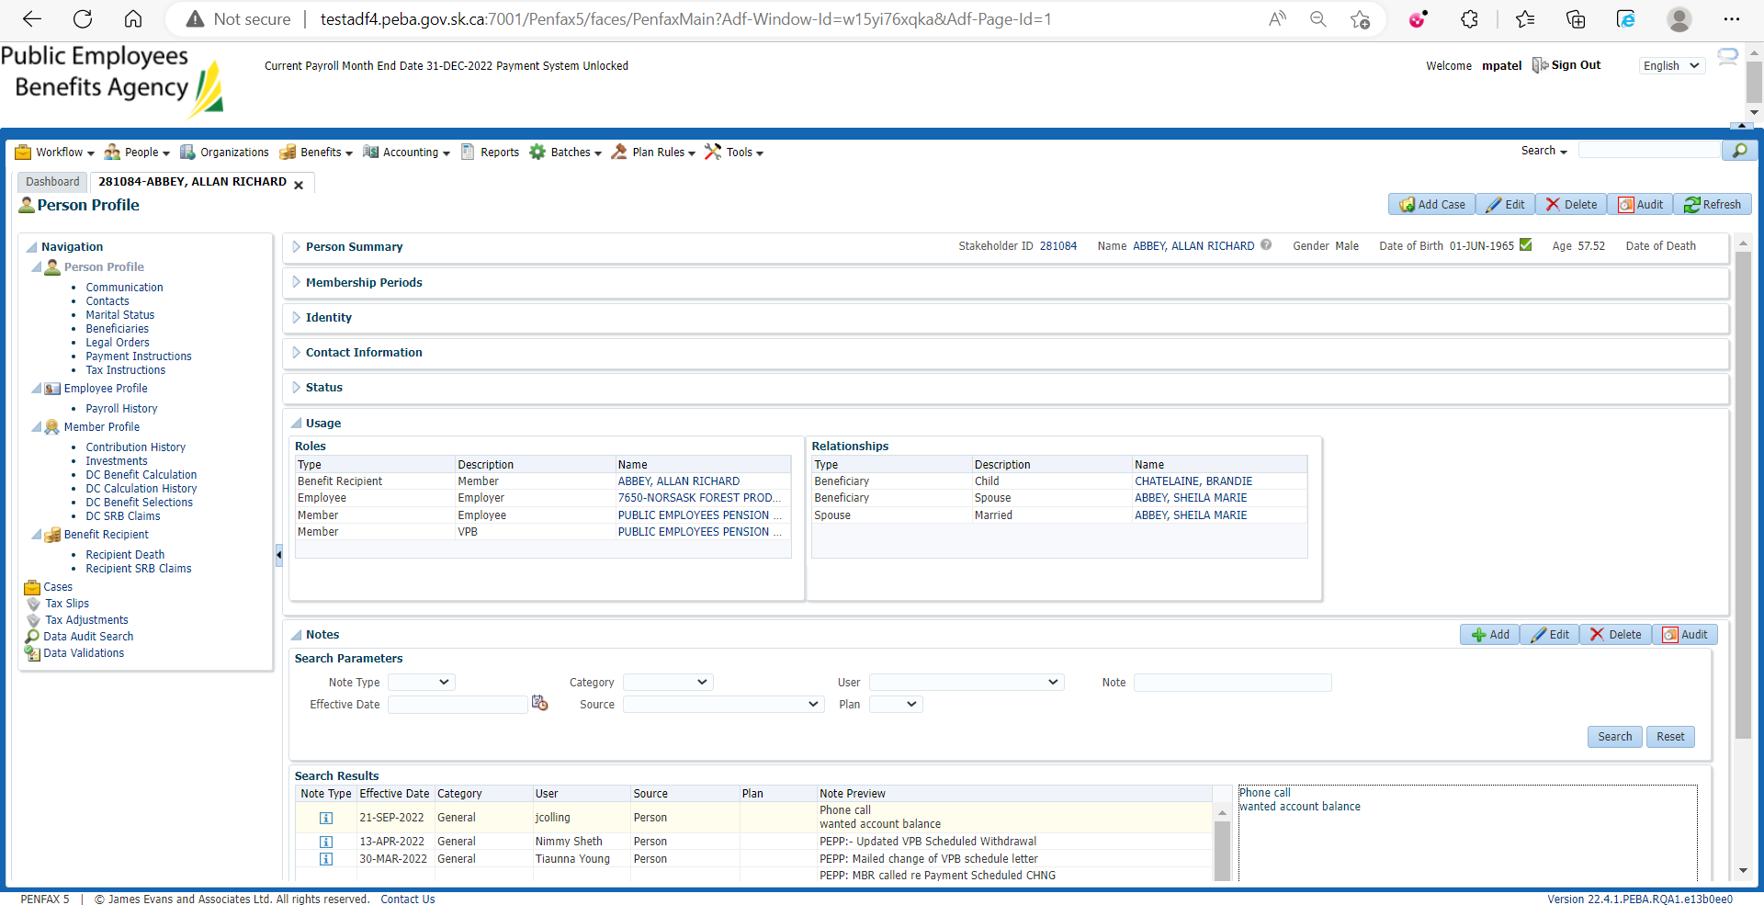

Go to DC Benefit Selection

Add new DC Benefit

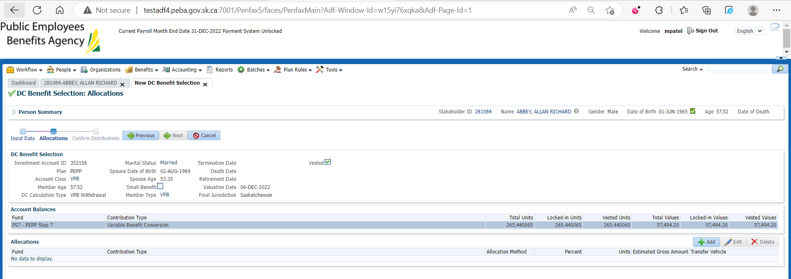

Add lump sum cash payment allocation and Save

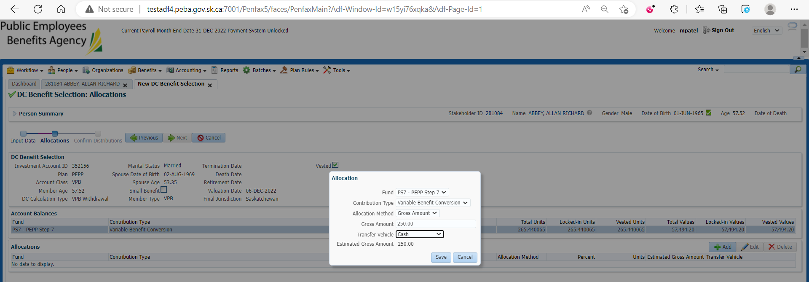

Submit for Approval and Approve it

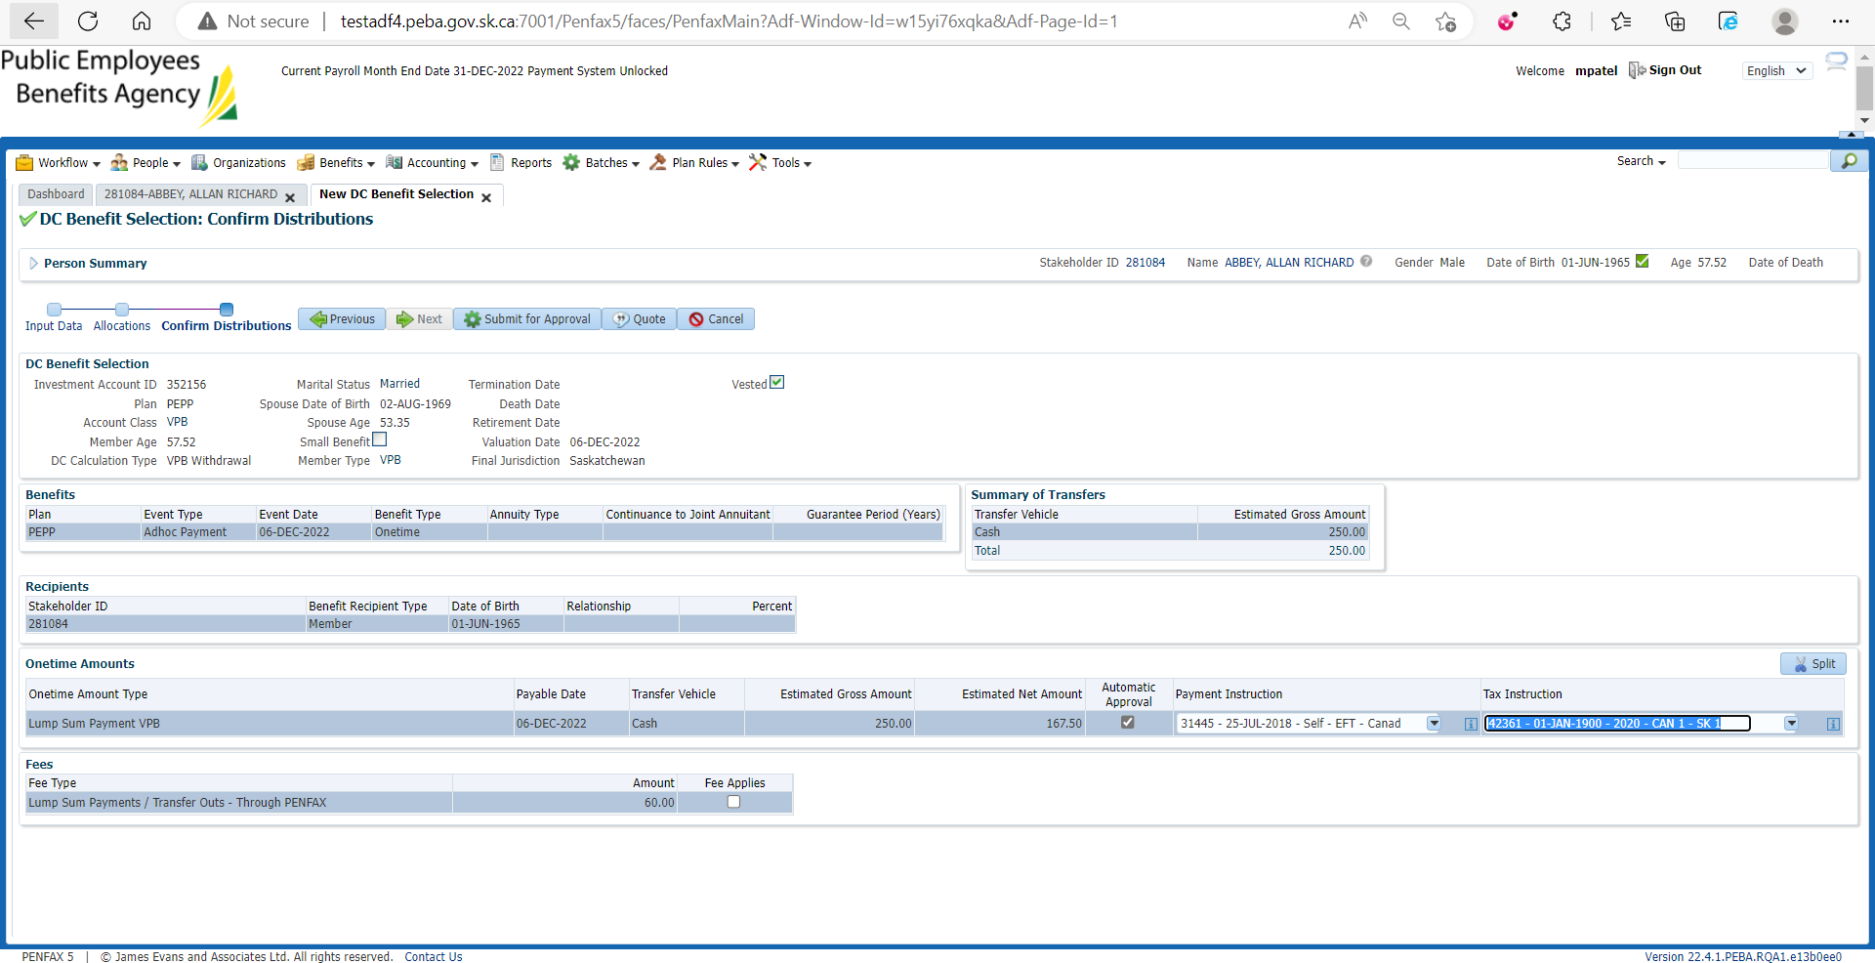

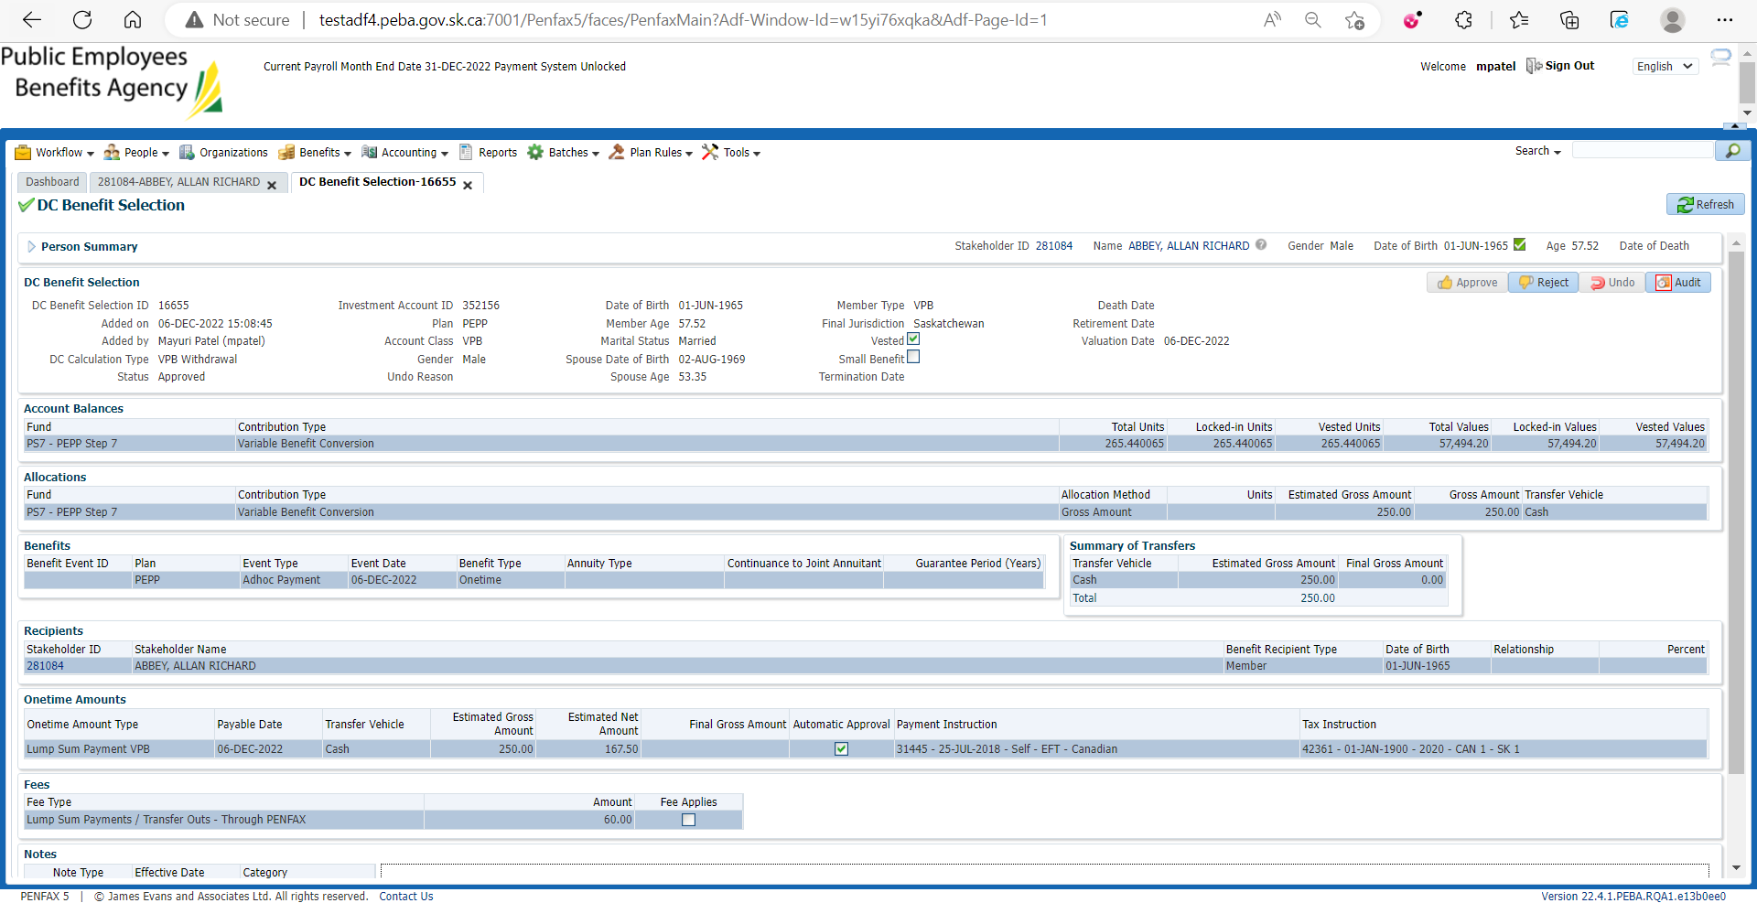

For Interfund Transfer

Go to Investments

Account instructions and Add new Account Instruction

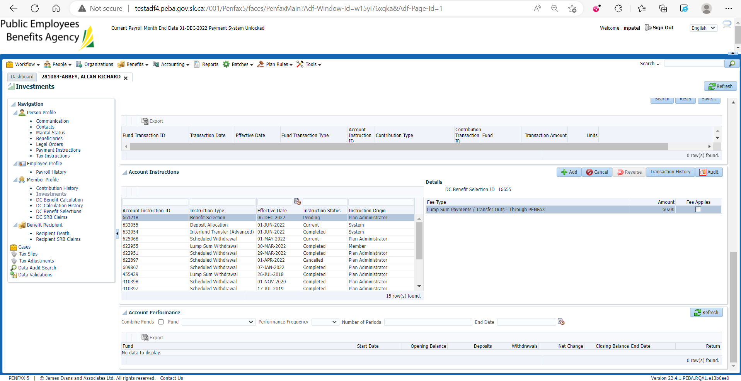

Enter details and Save

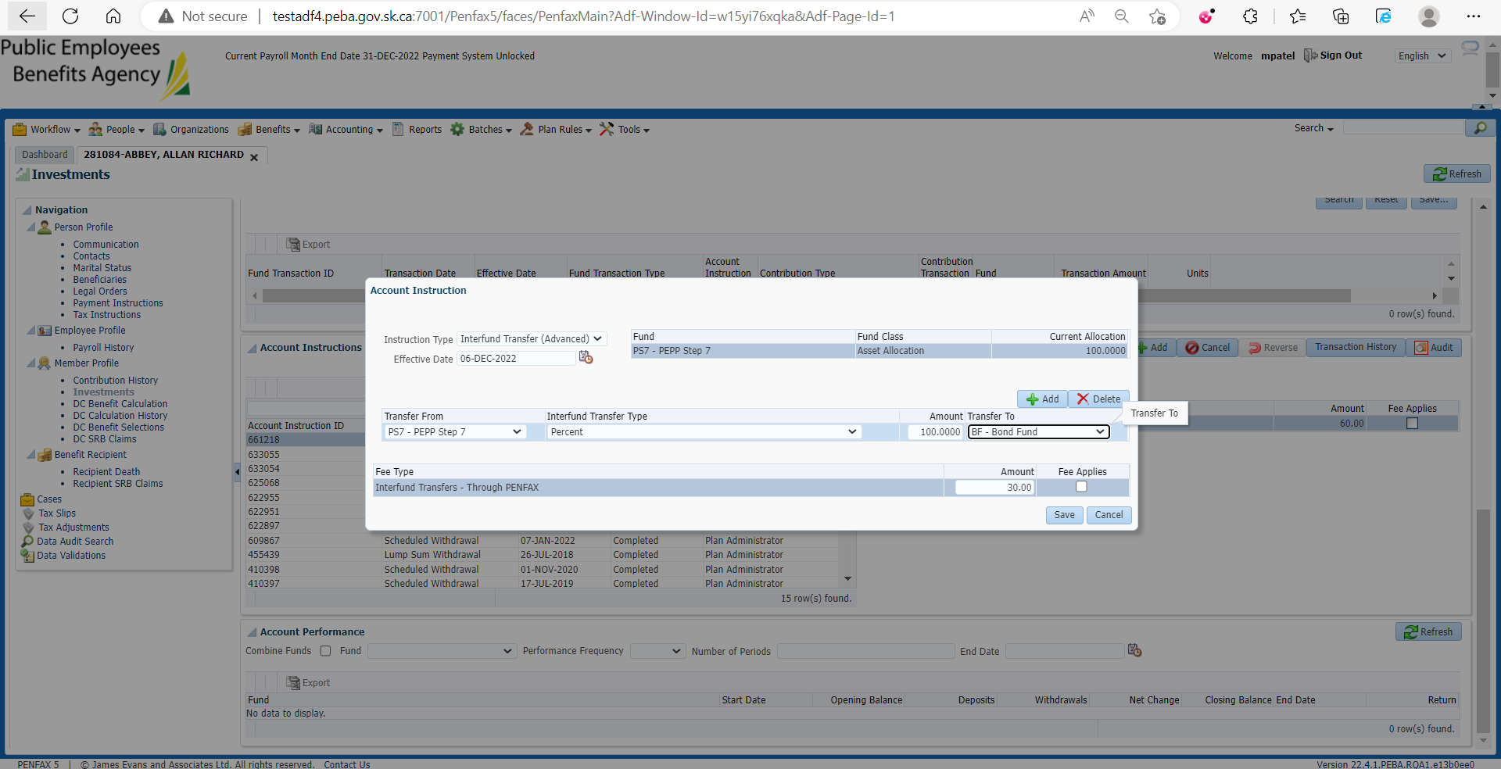

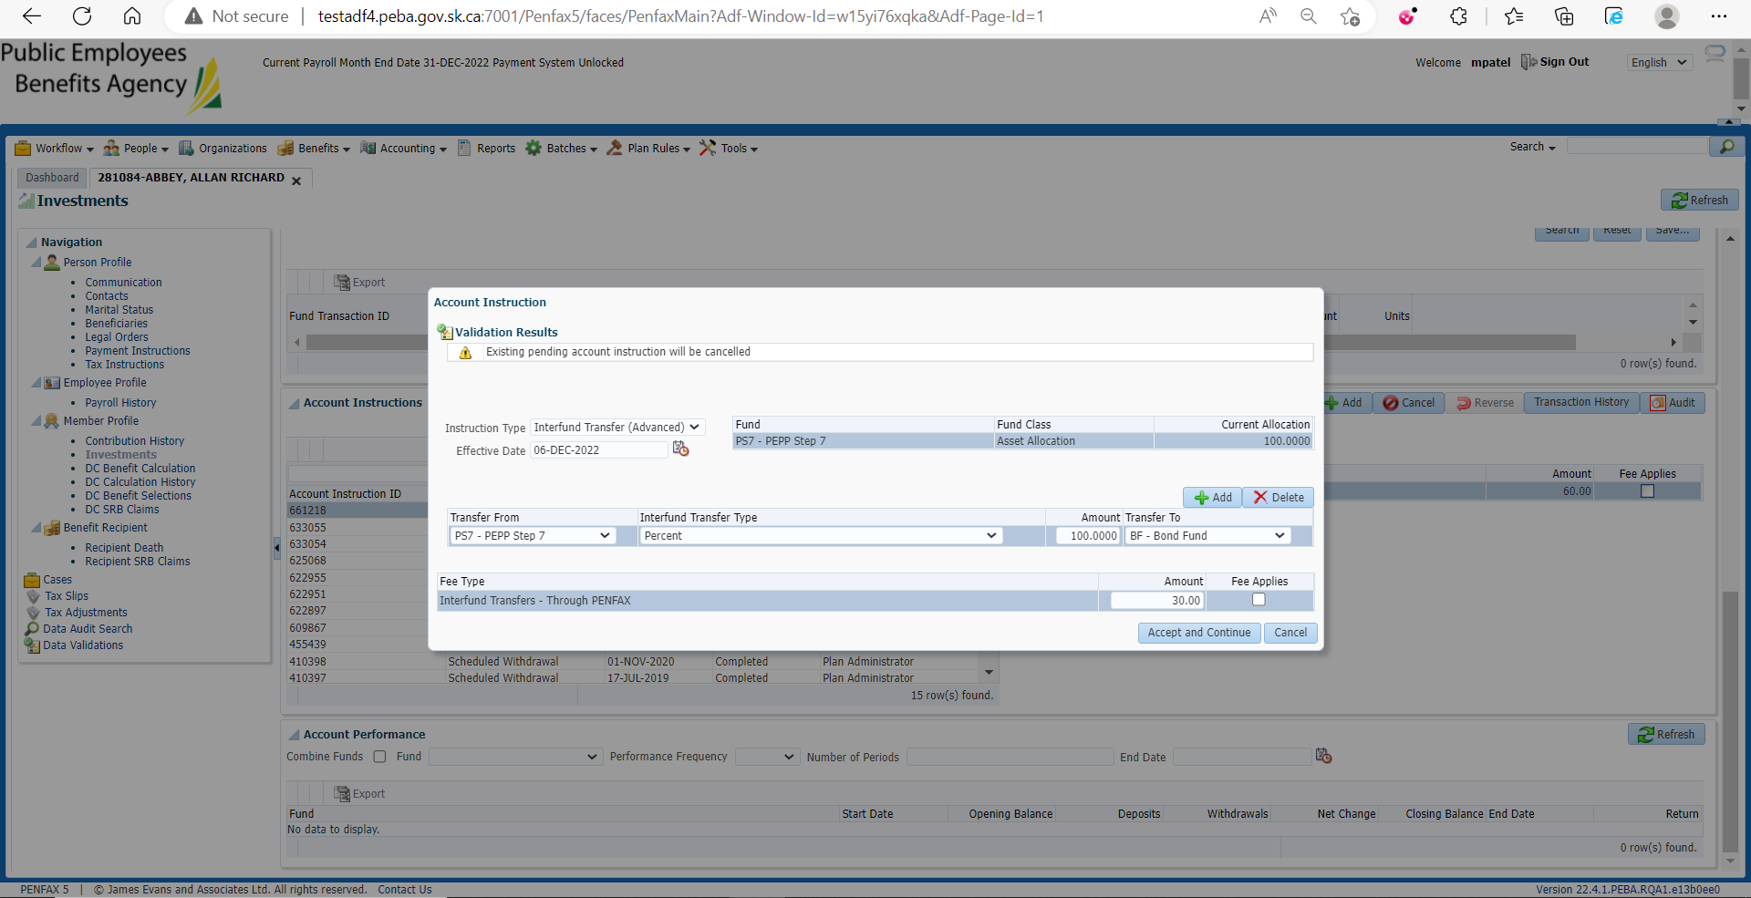

By adding Interfund Transfer Instruction, the previous Benefit Selection (Lump sum payment) is cancelled

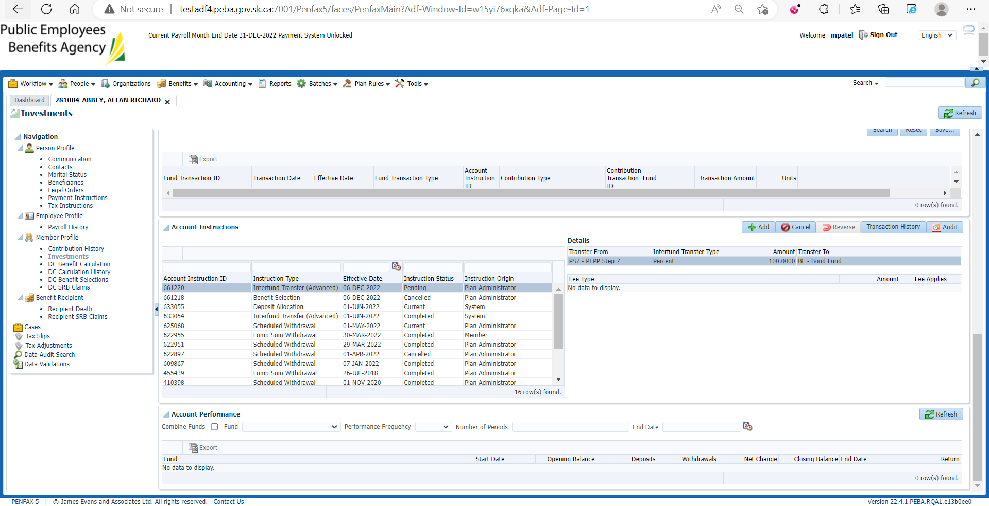

1. 1st Lump sum payment through Pen fax and 2nd Interfund Transfer through Pen web

Find a PEPP member for lump sum payment and Interfund transfer

Open that member profile in Penfax

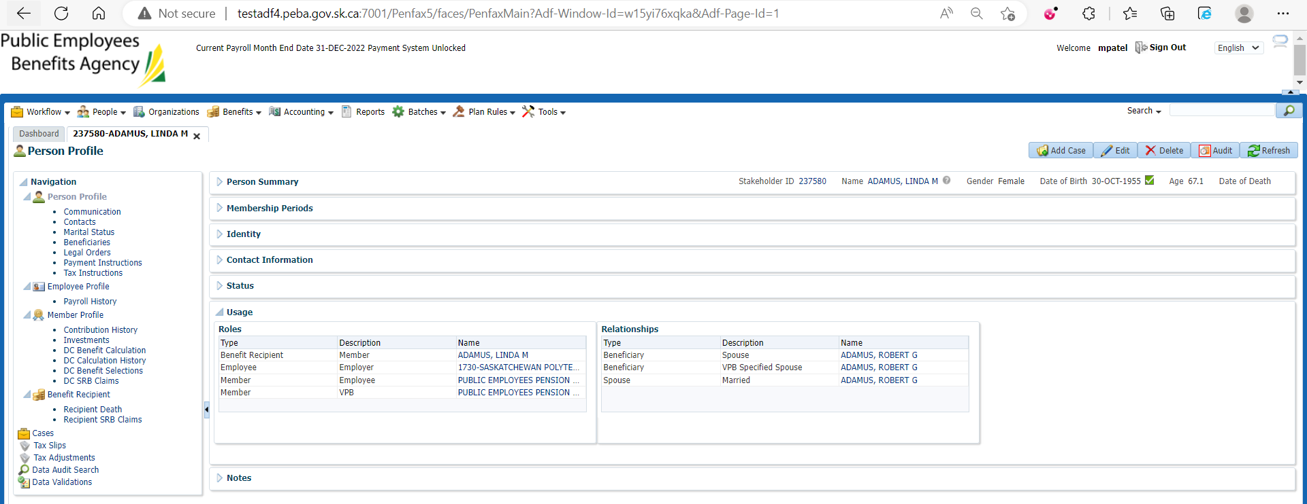

Go to DC Benefit Selection

Add new DC Benefit

Add lump sum cash payment allocation and Save

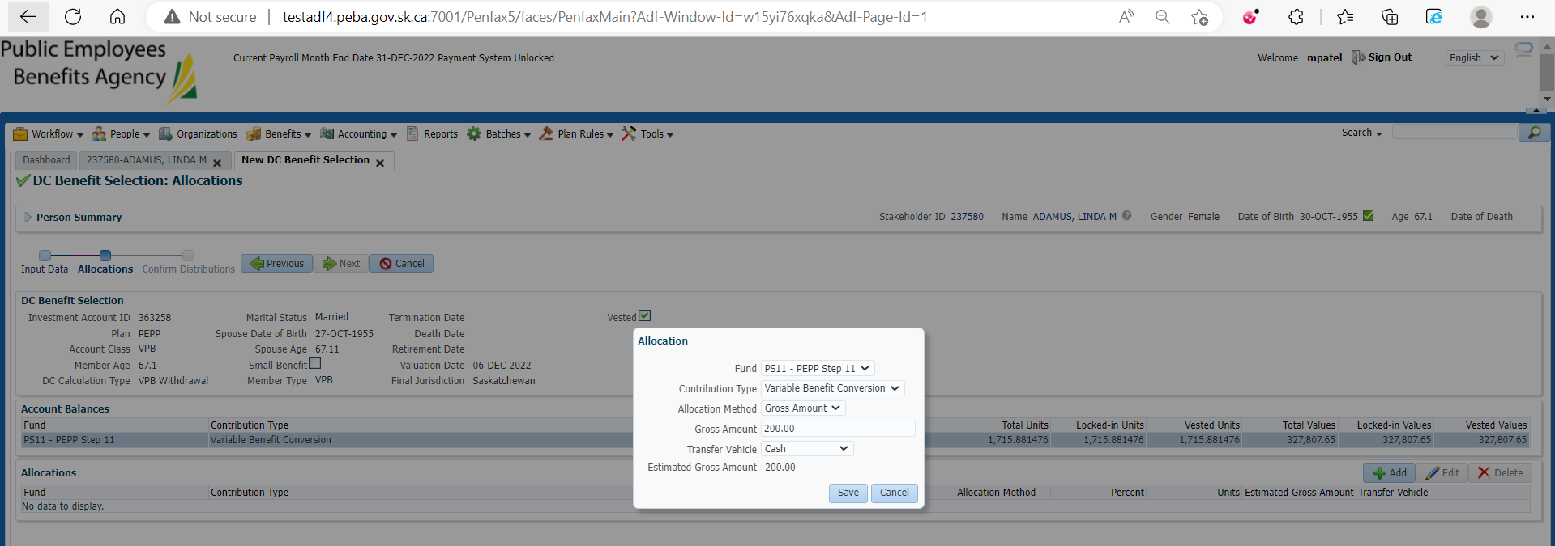

Submit for Approval and Approve it

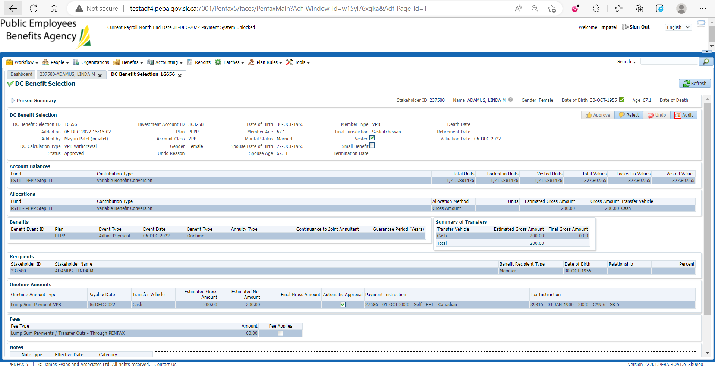

Under Investments🡪Account Instructions

Newly added lump sum payment Instruction is pending

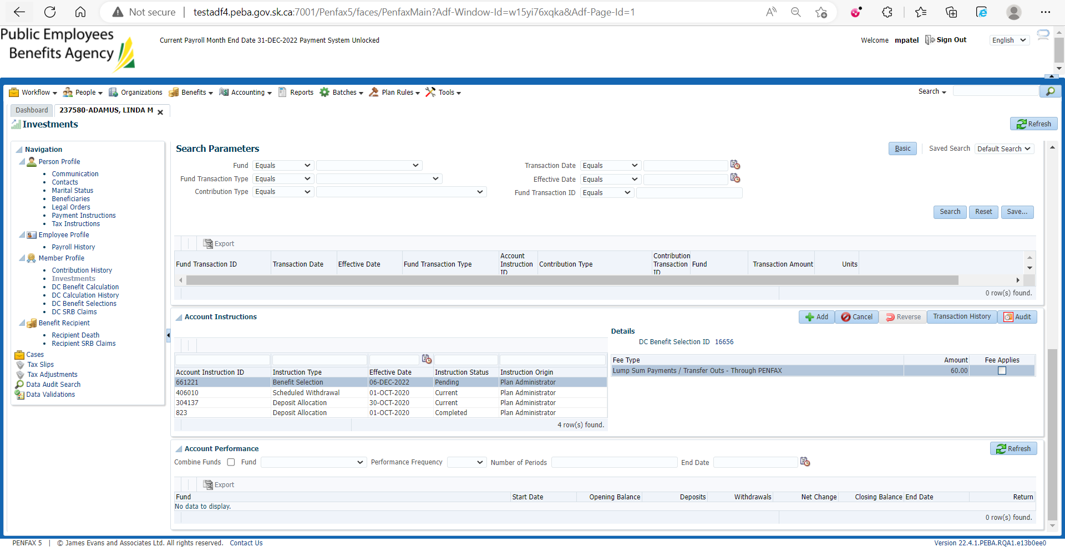

For Interfund Transfer through Pen web

Open that member Profile in Pen web

Go to My Investment

Change my Investment options

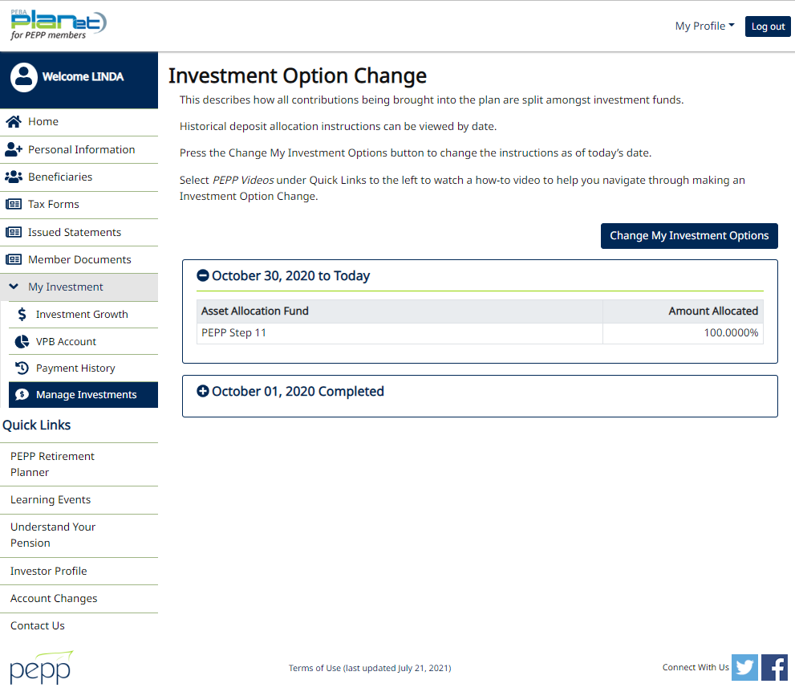

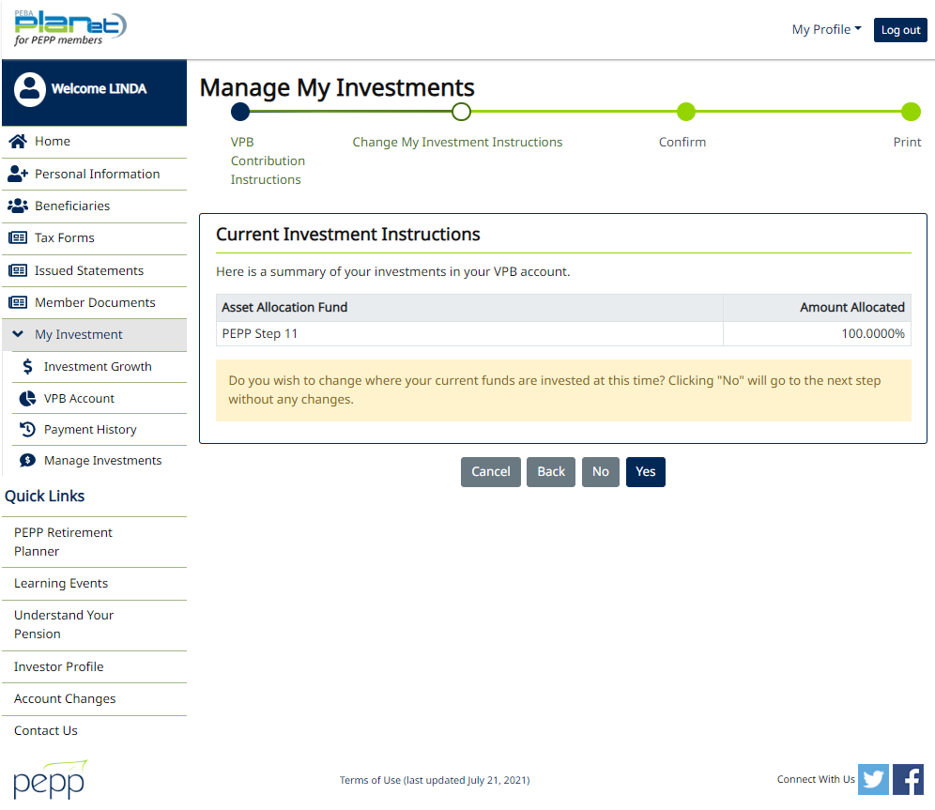

Change my Investment Instructions

Select any Specialty Fund to invest fund in and Next

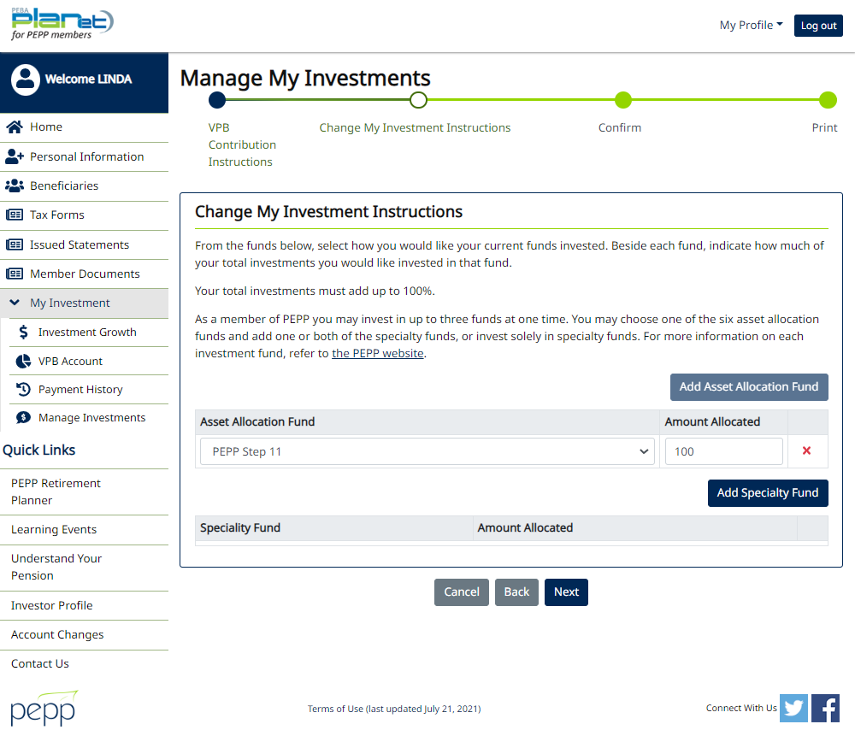

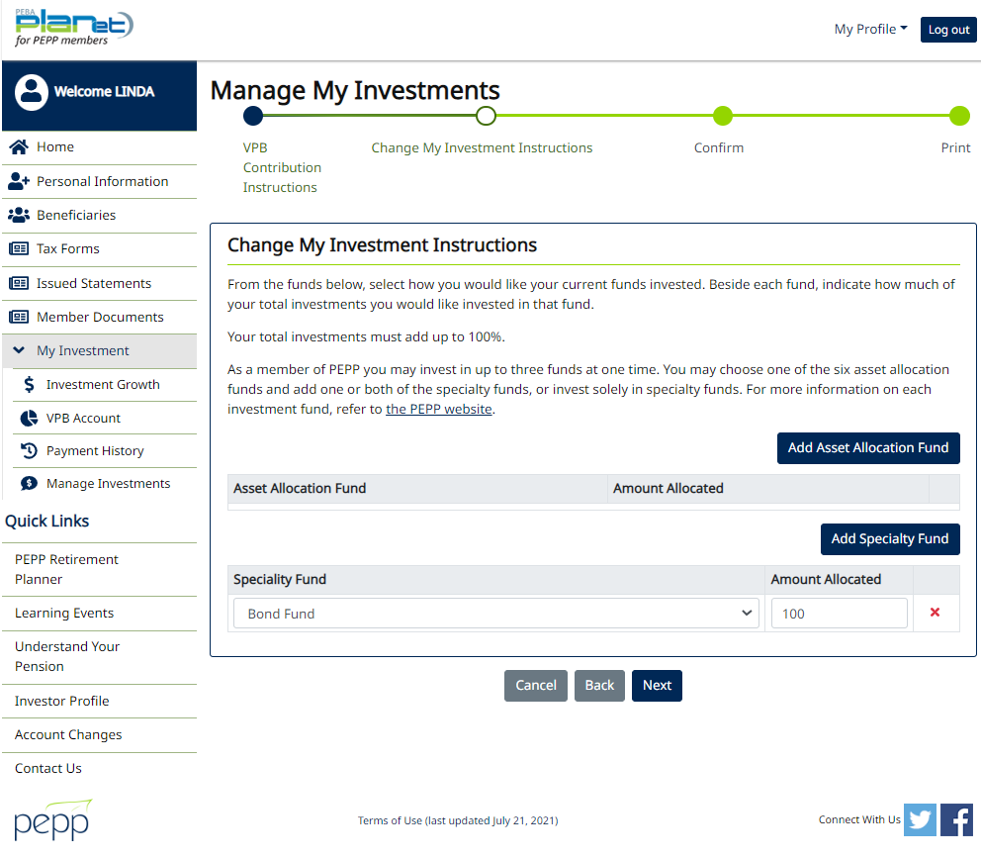

Confirm it

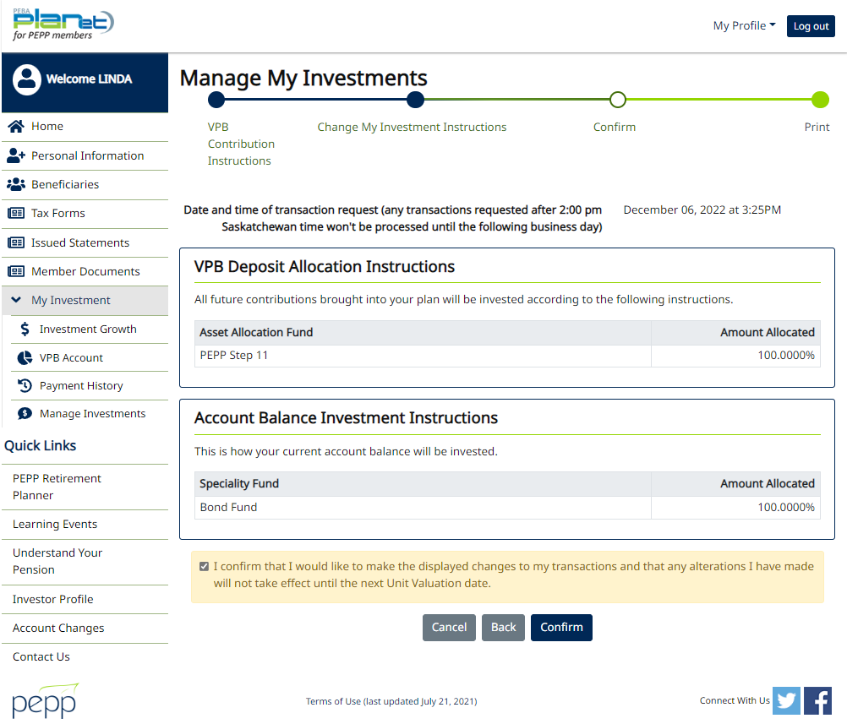

Warning Pops up that can not process request as pending transaction exists. Contact PEPP for assistance.

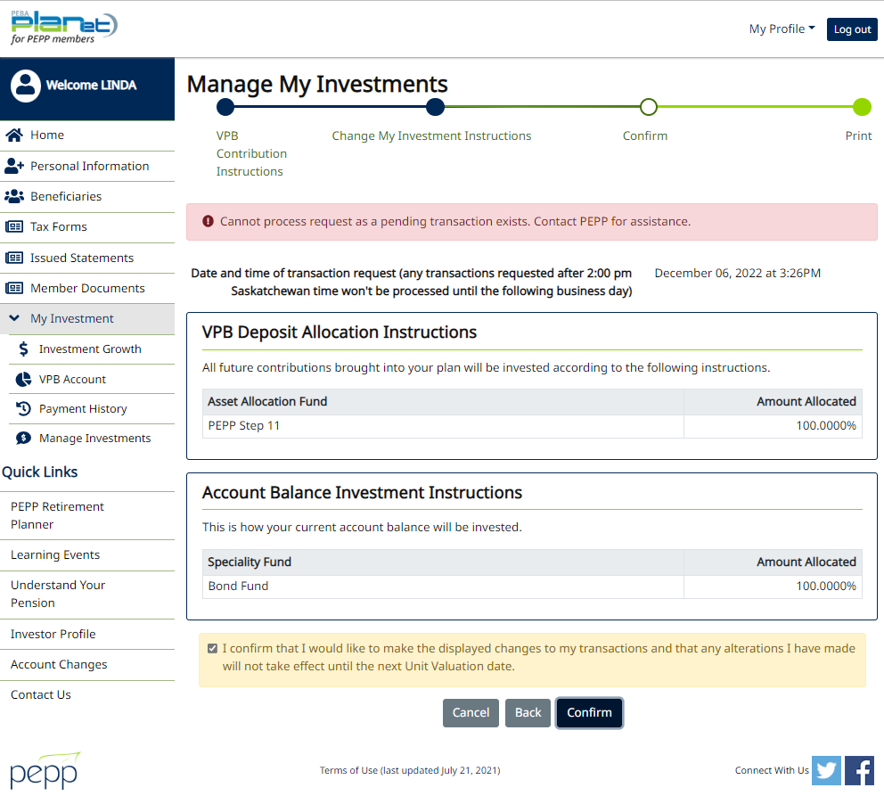

1. 1st Lump sum payment through Pen web and 2nd Interfund Transfer through Pen web

For Lump sum payment through Pen web and Inter fund Transfer through Pen web find any PEPP active member

Open that member profile in pen web



Request lump Sum Payment

Enter Requested payment Amount and Next

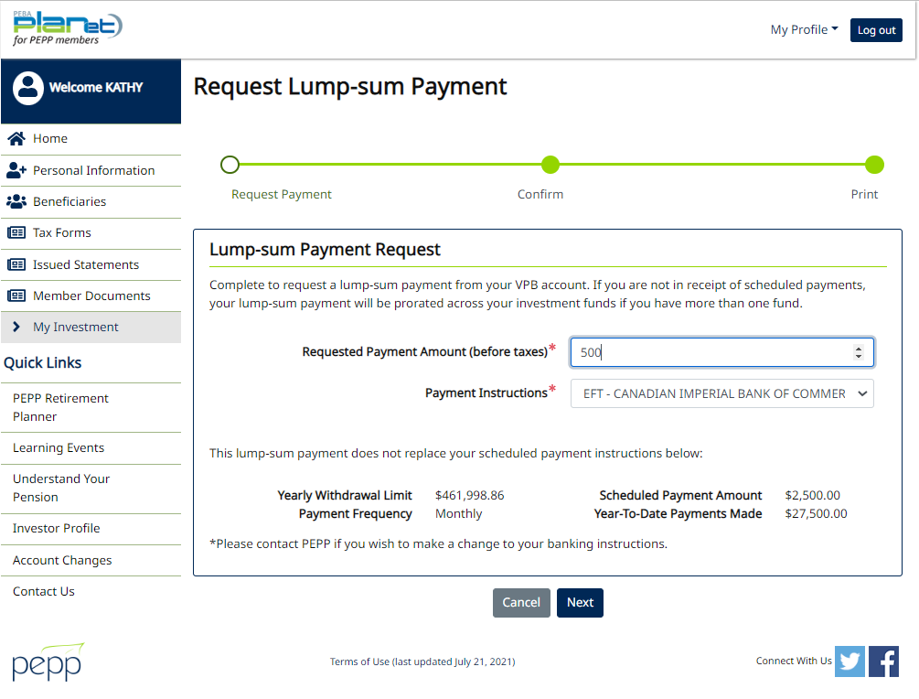

Confirm it

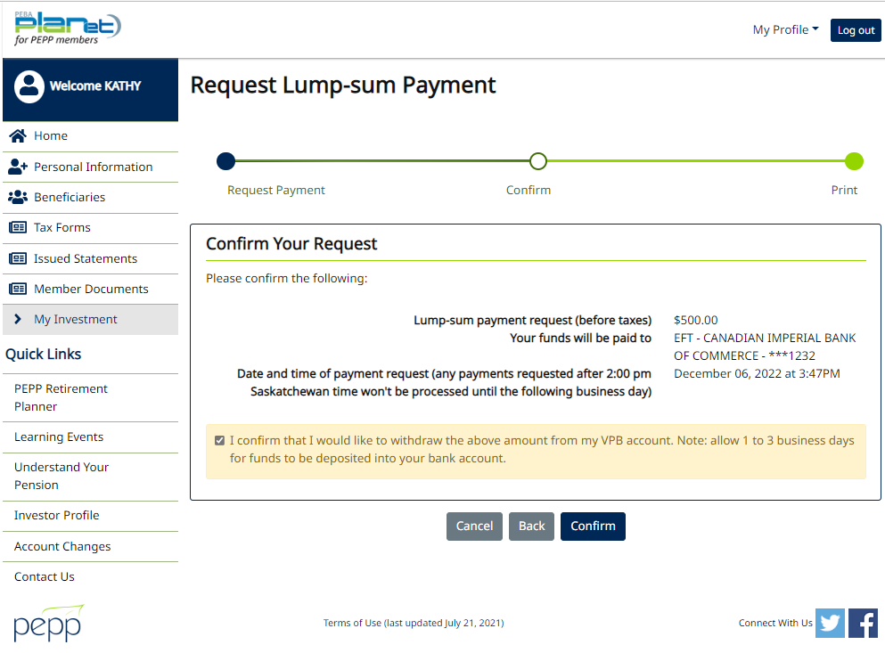

Print if needed

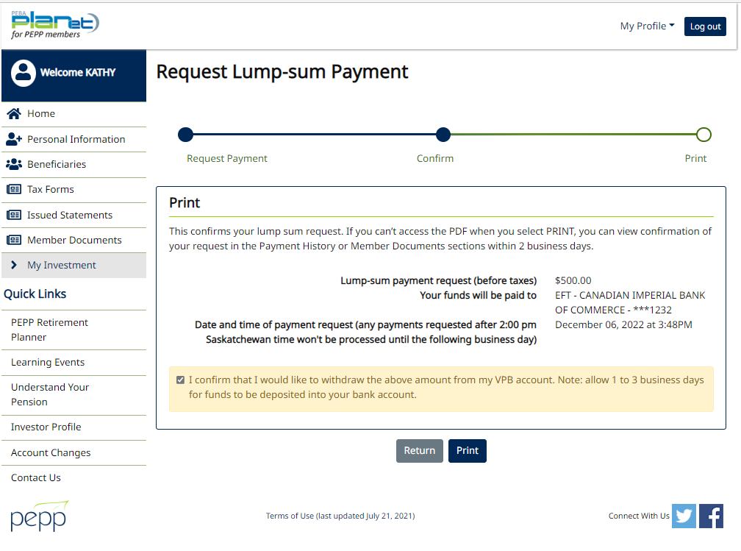

Newly added Lump sum payment through Pen web is now reflected as pending under Investments🡪 Account Instructions

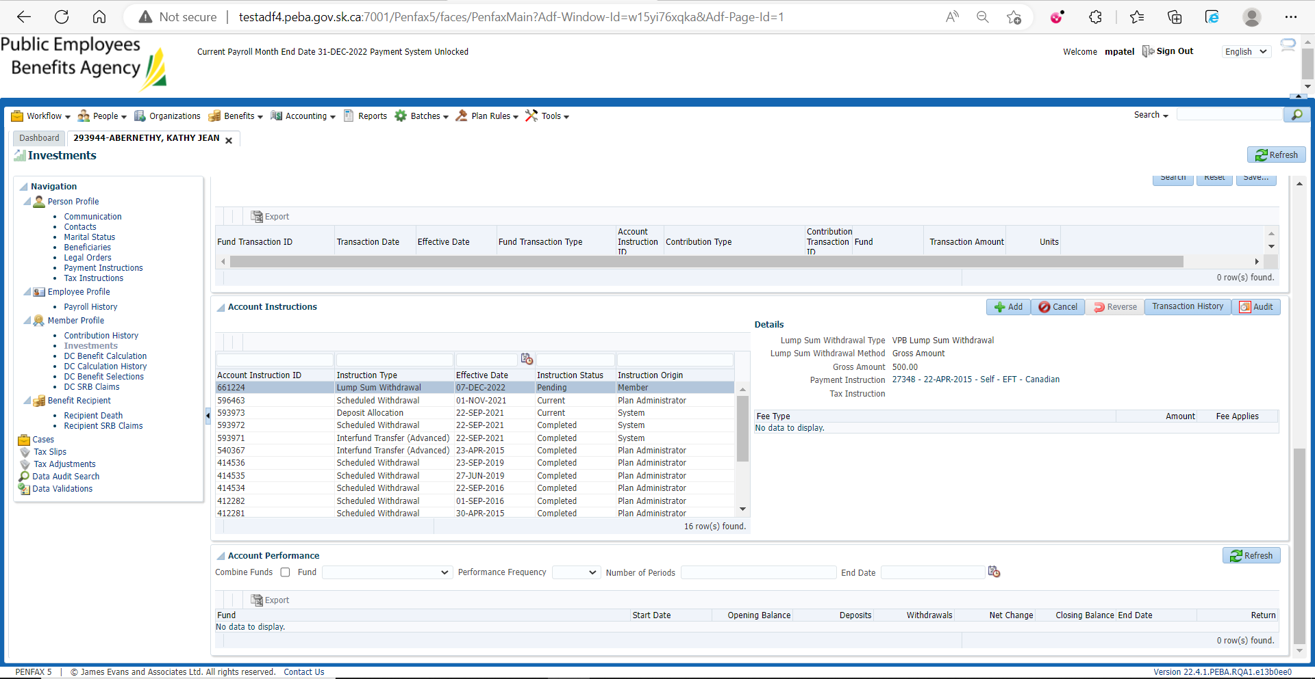

For interfund transfer through Pen web

Go to manage my Investments

Change my Investment Options

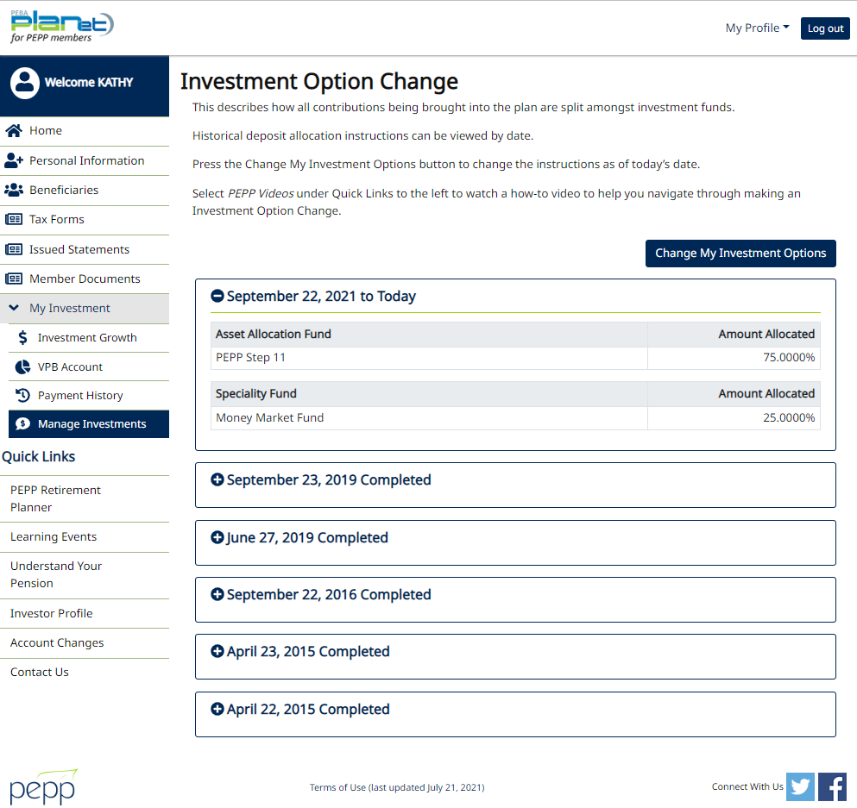

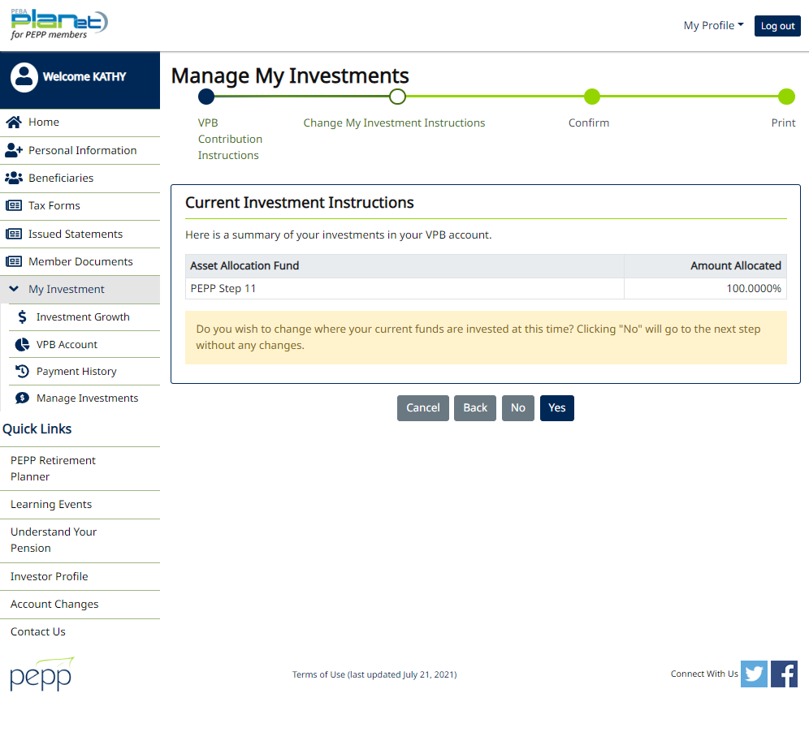

Select any specialty fund to invest fund in and Next

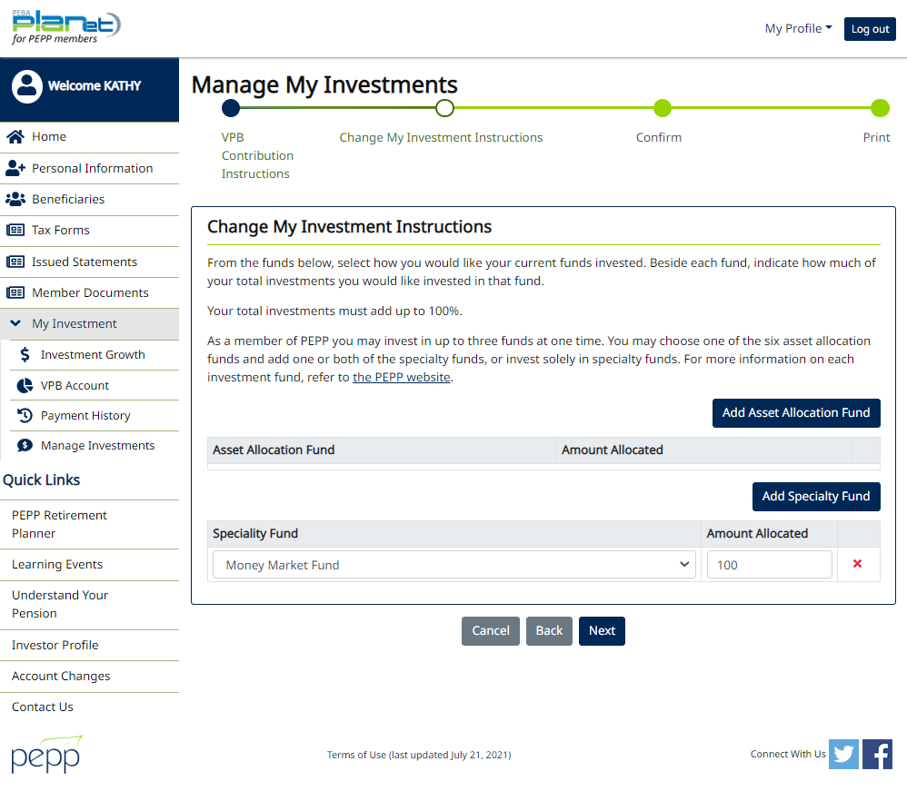

Confirm it

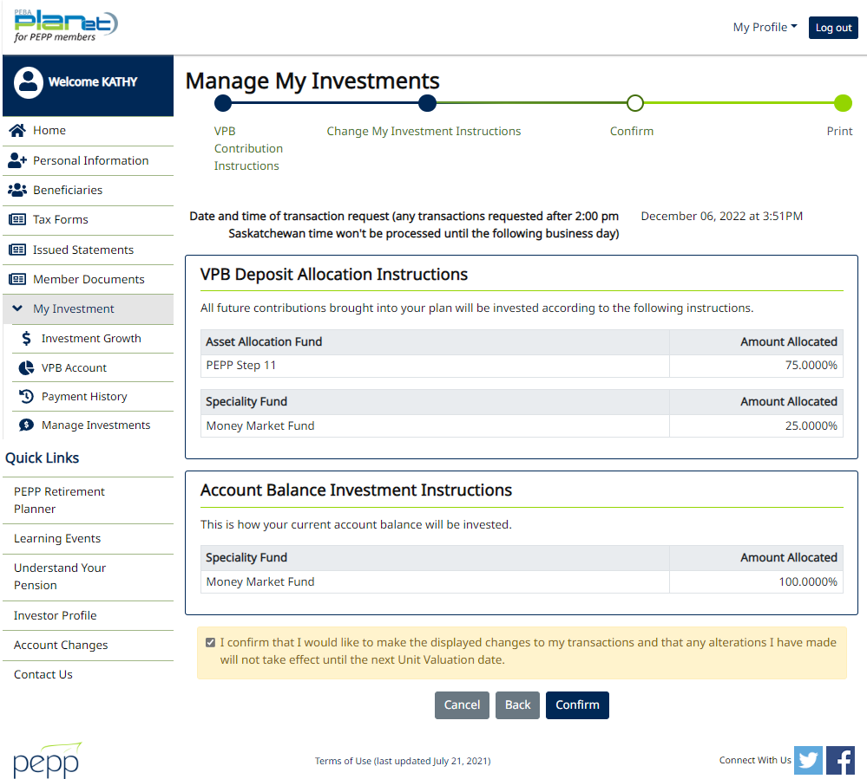

Warning pops up ‘Can not process request as a pending transaction exists. Contact PEPP for assistance.’

